Roll No-12

M.sc. 3rd semester

Date of Assignment-28/11/2020

Date of Submission-04/12/2020

**Experiment No -07**

**Topic**- Tracing the power curve of Exponential distribution.

**Problem** – A random sample of size 16 is drawn from a distribution with pdf



Draw the power curve for testing  against

(i) 

(ii) 

Assume, 

**Theory and Calculation**-

The BCR according to Neyman Pearson’s fundamental lemma is given by -



Now,  =

 (Taking logarithm on both sides)

**Case I:** If  then the C.R. is given by -



**Case II**: When then the C.R. is given by -



(i) Here, we have to test against. The critical region for testing this is given by -



Where $k_{1}$ is a constant to be determined such that the size of the CR is 0.05.







Where, 

Now, to obtain the value of $k_{2}$ we use the following R-command-

k2=qgamma(0.05,16,3.6)

k2

⸫ k2= 2.787766

⸫ The CR is given by -



The power of the test is given by -



= ; 

To draw the power curve, we construct the following table considering different trial values of

.

**TABLE 1**

|  | **theta_1** | **power_1** |
| --- | --- | --- |
|  |  |  |
| **1** | 3.7 | 0.36616699 |
| **2** | 3.8 | 0.34521723 |
| **3** | 3.9 | 0.32493218 |
| **4** | 4.0 | 0.30534186 |
| **5** | 4.1 | 0.28647044 |
| **6** | 4.2 | 0.26833648 |
| **7** | 4.3 | 0.25095318 |
| **8** | 4.4 | 0.23432870 |
| **9** | 4.5 | 0.21846648 |
| **10** | 4.6 | 0.20336556 |
| **11** | 4.7 | 0.18902102 |
| **12** | 4.8 | 0.17542423 |
| **13** | 4.9 | 0.16256336 |
| **14** | 5.0 | 0.15042361 |
| **15** | 5.1 | 0.13898768 |
| **16** | 5.2 | 0.12823608 |
| **17** | 5.3 | 0.11814744 |
| **18** | 5.4 | 0.10869889 |
| **19** | 5.5 | 0.09986633 |
| **20** | 5.6 | 0.09162473 |
| **21** | 5.7 | 0.08394836 |
| **22** | 5.8 | 0.07681109 |
| **23** | 5.9 | 0.07018657 |
| **24** | 6.0 | 0.06404845 |
| **25** | 6.1 | 0.05837055 |
| **26** | 6.2 | 0.05312702 |
| **27** | 6.3 | 0.04829248 |
| **28** | 6.4 | 0.04384214 |
| **29** | 6.5 | 0.03975190 |
| **30** | 6.6 | 0.03599843 |

**Programming in R for case 1-**

library('ggplot2')

k2 = qgamma(0.05,16,3.6)

k2

n = 16

theta_1 = seq(from=3.7, by=0.1, length.out=30)

theta_1

power_1 = mat.or.vec(30,1)

for(i in 1:30){

power_1[i] = pgamma(k2, theta_1[i])}

power_1

Table = data.frame(theta_1,power_1)

Table

View(Table)

ggplot(data=Table,mapping=aes(x=theta_1,y=power_1))+geom_point()+geom_line()

data.frame(theta_1)

data.frame(power_1)

**Power curve by using ggplot 2**

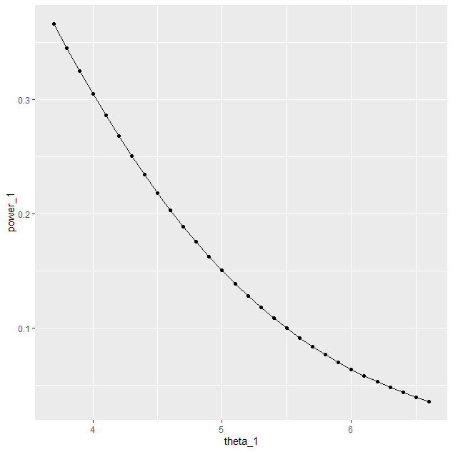

**Power curve generated by using Tableau**

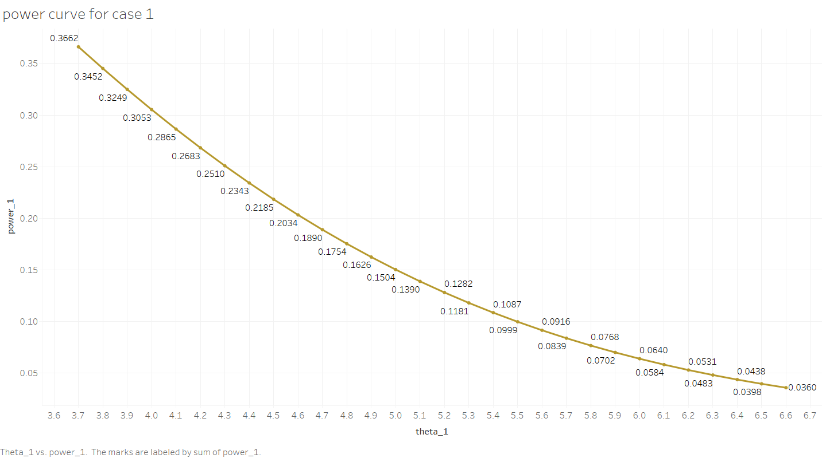

(ii) Here we are testing  against . The CR for testing this is given by -



Where  is a constant to be determined such that the size of the CR is 0.05.





 where, X~gamma(16, 3.6)





Now, to obtain the value of , we use the following R command-

k3=qgamma(0.95,16,3.6)

k3

k3= 6.415869

The CR is given by -



And the power of the test is given by -





 Where, ~ gamma(16, )



To draw the power curve, we construct the following table considering different trial values of 

**TABLE 2**

|  | **theta_2** | **power_2** |
| --- | --- | --- |
|  |  |  |
| **1** | 0.5 | 0.0003407889 |
| **2** | 0.6 | 0.0004948788 |
| **3** | 0.7 | 0.0006927973 |
| **4** | 0.8 | 0.0009426972 |
| **5** | 0.9 | 0.0012535981 |
| **6** | 1.0 | 0.0016353975 |
| **7** | 1.1 | 0.0020988716 |
| **8** | 1.2 | 0.0026556663 |
| **9** | 1.3 | 0.0033182768 |
| **10** | 1.4 | 0.0041000169 |
| **11** | 1.5 | 0.0050149766 |
| **12** | 1.6 | 0.0060779687 |
| **13** | 1.7 | 0.0073044639 |
| **14** | 1.8 | 0.0087105158 |
| **15** | 1.9 | 0.0103126751 |
| **16** | 2.0 | 0.0121278943 |
| **17** | 2.1 | 0.0141734240 |
| **18** | 2.2 | 0.0164667004 |
| **19** | 2.3 | 0.0190252271 |
| **20** | 2.4 | 0.0218664500 |
| **21** | 2.5 | 0.0250076285 |
| **22** | 2.6 | 0.0284657035 |
| **23** | 2.7 | 0.0322571636 |
| **24** | 2.8 | 0.0363979101 |
| **25** | 2.9 | 0.0409031249 |
| **26** | 3.0 | 0.0457871388 |
| **27** | 3.1 | 0.0510633052 |
| **28** | 3.2 | 0.0567438782 |
| **29** | 3.3 | 0.0628398974 |
| **30** | 3.4 | 0.0693610808 |

**Programming in R for case 2-**

library('ggplot2')

k3 = qgamma(0.95,16,3.6)

k3

n = 16

theta_2 = seq(from=0.5, by=0.1, length.out=30)

theta_2

power_2 = mat.or.vec(30,1)

for(i in 1:30){

power_2[i]=1-pgamma(k3, theta_2[i])}

power_2

Table_2 = data.frame(theta_2,power_2)

Table_2

View(Table_2)

ggplot(data=Table_2,mapping=aes(x=theta_2,y=power_2))+geom_point()+geom_line()

data.frame(theta_2)

data.frame(power_2)

**Power curve by using ggplot 2**

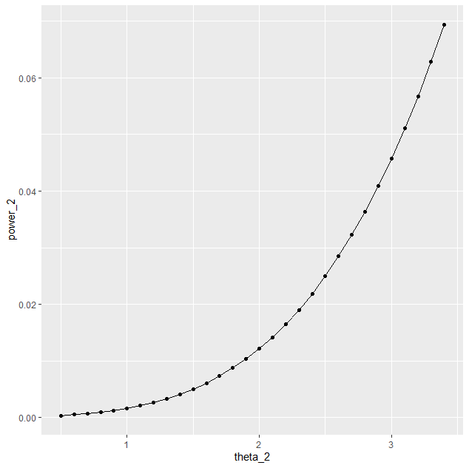

**Power curve generated by using Tableau**

